Marwadi University
Faculty of Computer Applications

BCA 4E Python Mid-1 Exam

Enrollment No. : 92400527213
Name : Jennifer Mkolo
Class : 4E
Date : 12 March

Answer – 1
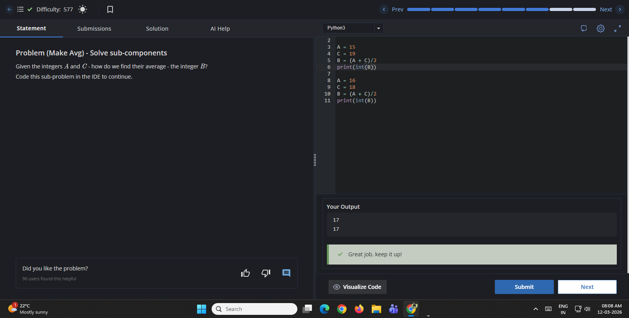
Answer – 2
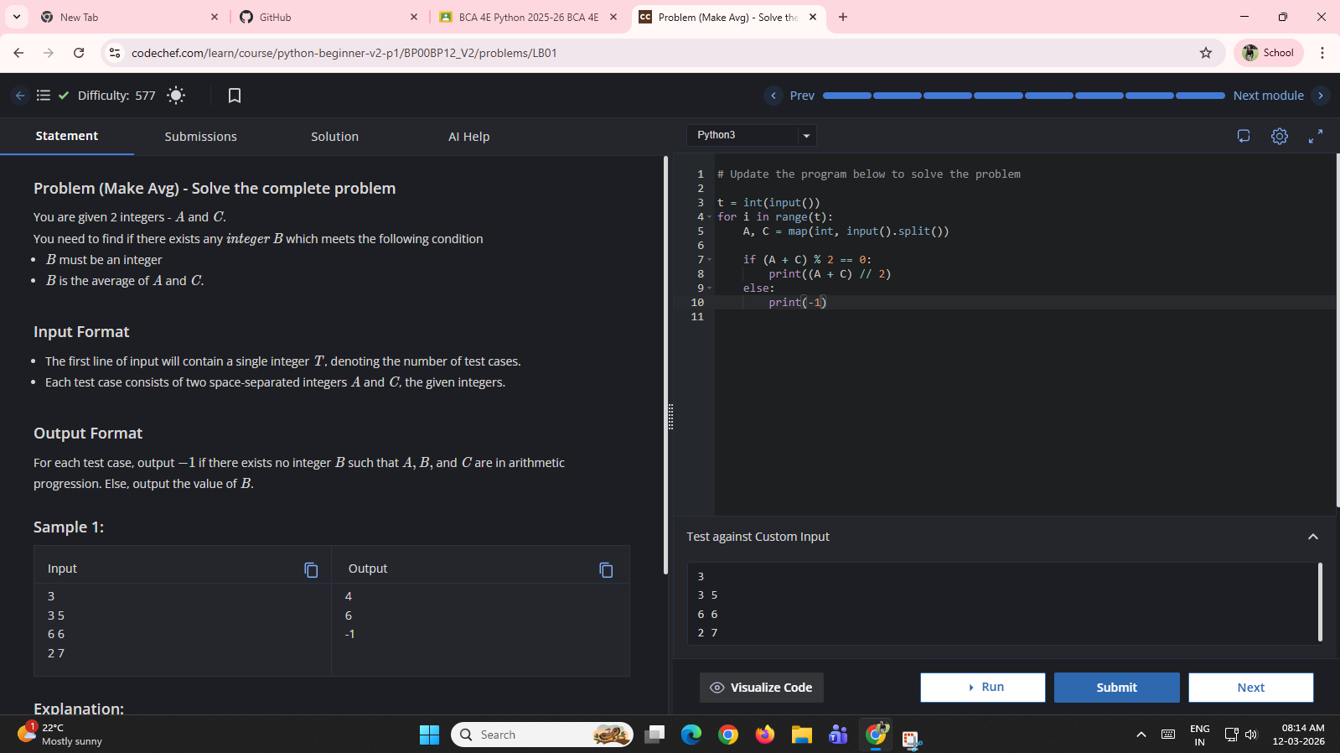
Answer – 3
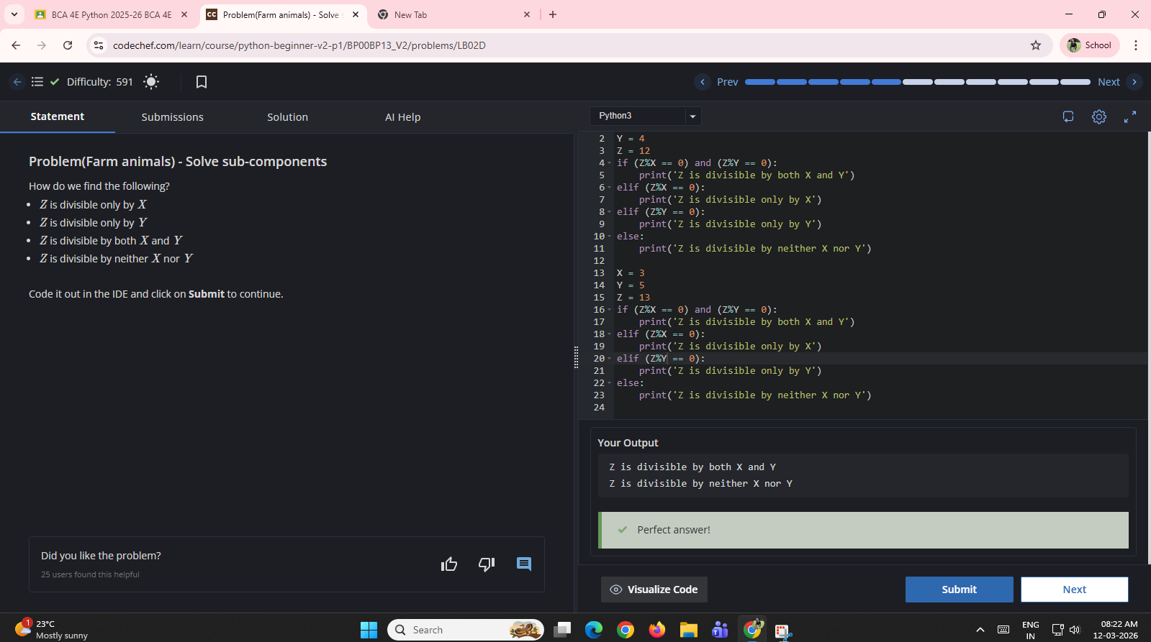
Answer – 4
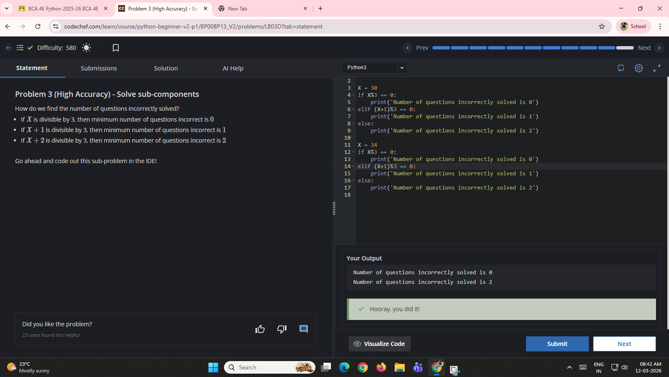
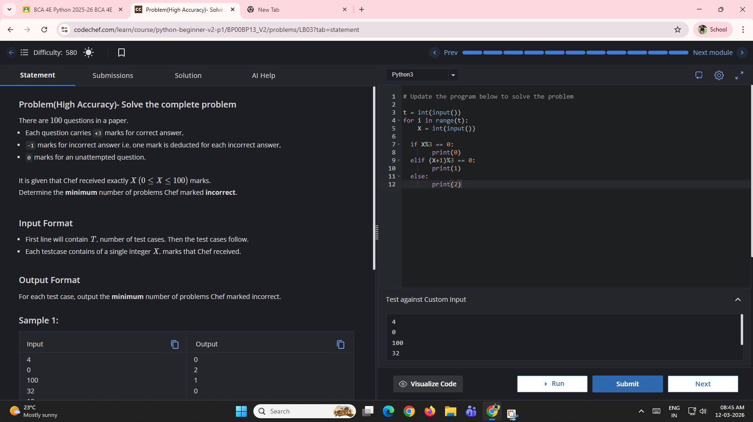
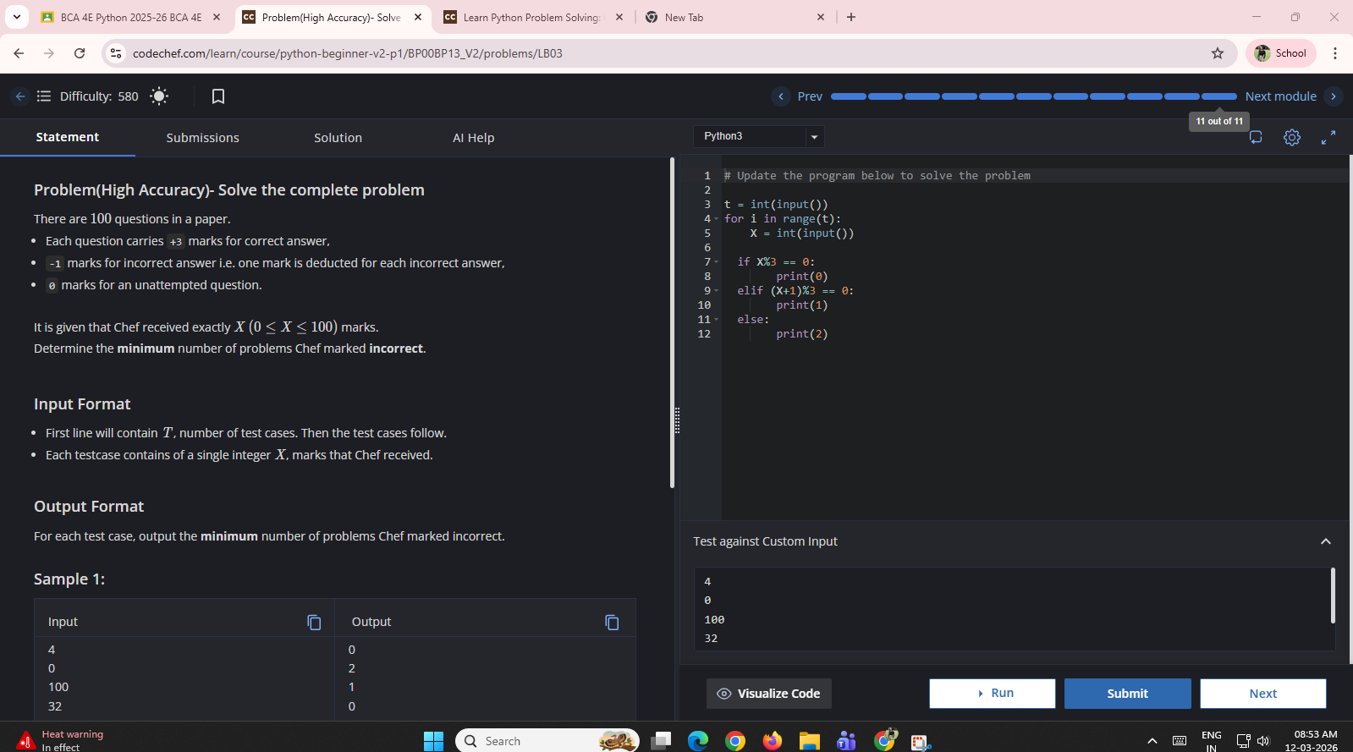
Answer - 5

